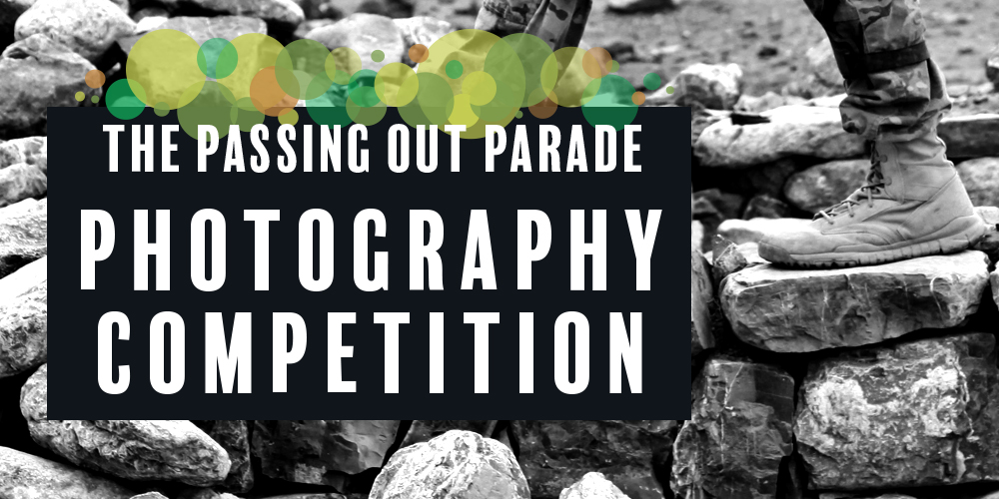

The Passing Out Parade project captures and celebrates local stories of how significant events of war have shaped our history and who we are today.

South West Arts is encouraging photographers of all ages to enter the Passing Out Parade Photography Competition. Artists invited to submit a digital photograph that reflects the impact of experiences of war in the South West NSW region.

First prize $250 - Under 15 prize $150 - Plus other additional prizes

The photographs will form an exhibition that will support the Passing Out Parade project and will be exhibited online and in a travelling exhibition across the region.

Entries close midnight Sunday 19th February 2018

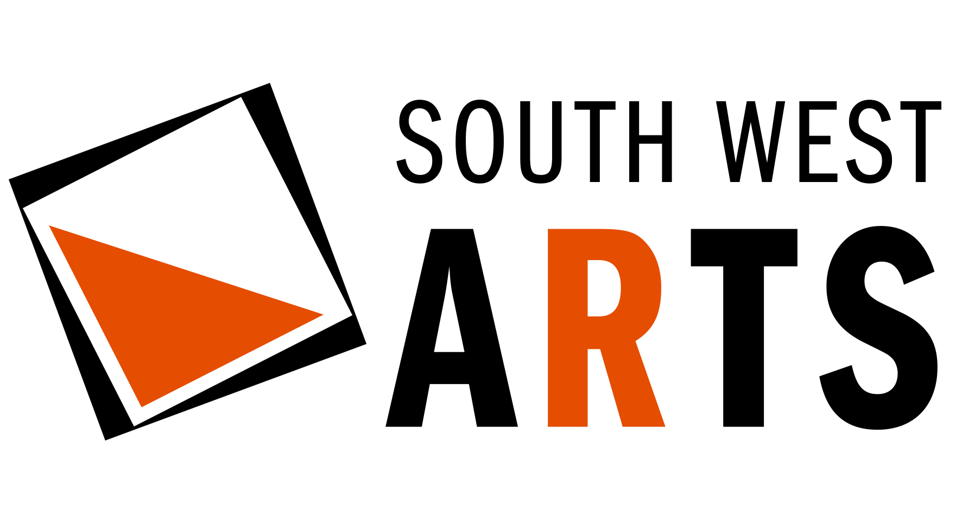

Conditions of Entry:
Winners
- Categories: Open, Under 15 years of age
- Winners will be announced Monday 23 April 2018
- OPEN: First Prize: $250 Second Prize: $150 | UNDER 15: First Prize: $150 | Plus additional non-cash prizes
Entries
- The Passing Out Parade Photography Competition is open to local and non-local participants, but the photograph(s) must take inspiration from the criteria provided.
- Works must reflect on the theme of the impact of experiences of war in the region of South West NSW.
- Works must be submitted electronically in accordance to the following guidelines:
  - Medium to high quality in JPEG file format
  - Digital file emailed to promo@southwestarts.com.au
  - Artists must submit the entry form including an artist statement about their work’s inspiration
  - Must be received by midnight Sunday 19th February 2018
- Physical photographs will not be accepted for entry.
- Multiple entries are accepted when submitted as individual entries.
- All works submitted for the Passing Out Parade Photography Competition must be original works executed by the artist whose name appears on the entry form.
Closing date for entries
- Entries must be received by midnight Sunday 19th February 2018
- Entries received after the closing date will not be accepted.
Judging
- The panel of judges, appointed by South West Arts, will comprise three people, representing the arts and local communities.
- Entries will be judged according to the following criteria:
  - Response to theme of Passing Out Parade
  - Ability to communicate the inspiration
  - Creativity of expression
  - Application of technique
- The judging panel shall solely determine the winning entries.
- The judging panel’s decision is final and no correspondence will be entered into.
Exhibition
- Selected artworks will be exhibited online as part of the Passing Out Parade project at southwestarts.com.au
- Selected works will be included in the CD-ROM of the Passing Out Parade audio recordings
- Selected works will form a touring exhibition in local RSL Clubs across the region.
Reproduction of Works
- Each entrant specifically permits and authorises South West Arts to reproduce his or her artwork by print or electronic media for publicity purposes, reports, catalogues and any other publications related to the Passing Out Parade project and exhibition. Due attribution will be made to the artist.
Privacy Statement
Personal information requested such as name and address, is collected for the purpose of registering applications for the Passing Out Parade Photography Competition. The personal information collected will not be used for any other purpose or disclosed except as may be required by law. By agreeing to the Conditions of Entry you allow South West Arts to publish your name and town alongside your exhibited artwork.

South West Arts Inc. 122 End Street, Deniliquin NSW 2710 southwestarts.com.au

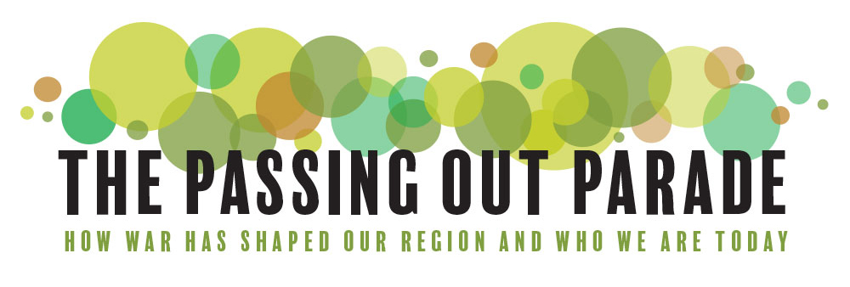

PASSING OUT PARADE PHOTOGRAPHIC COMPETITION ENTRY FORM
NAME
address
Phone
email
Category | ( ) OPEN ( ) UNDER 15 YEARS OF AGE

TITLE OF YOUR PHOTOGRAPH:
INSPIRATION FOR YOUR PHOTOGRAPH:

I have read and agree to the published Conditions of Entry of the South West Passing Out Parade Photographic Exhibition and certify that the above information is correct.

SIGNED: DATE:

NAME: (printed)

