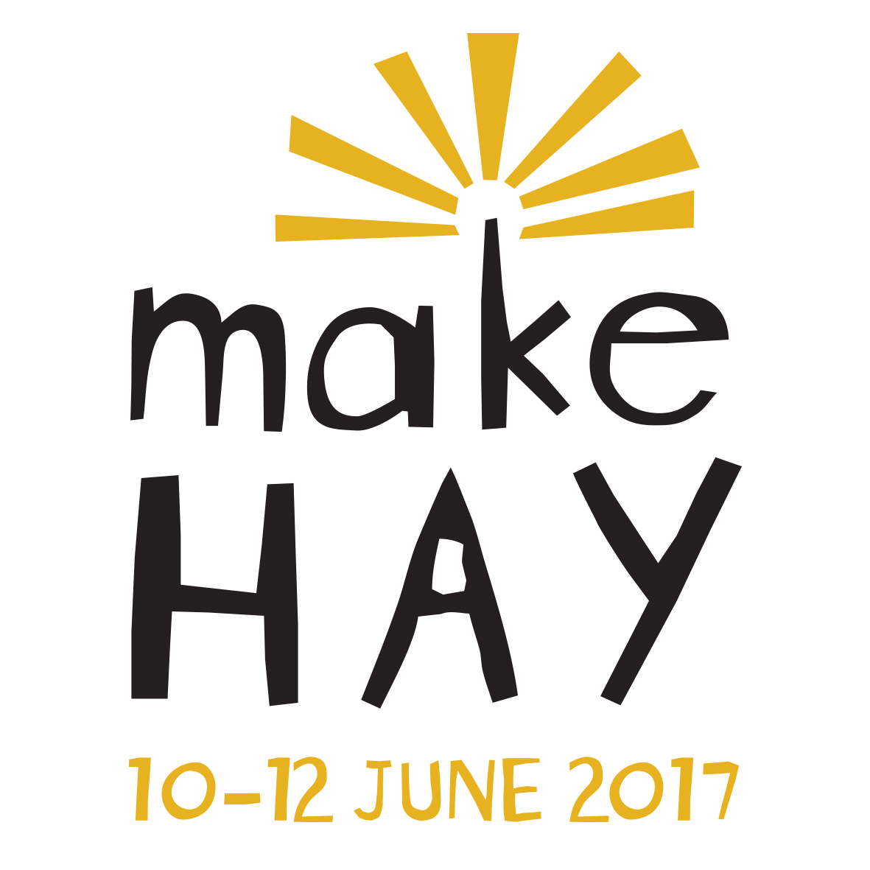

HOST A WORKSHOP
Expression of Interest form

Name
Phone
Email

Please describe your proposed workshop

Who would your workshop be for?
eg. Children, Artists, Writers

How many participants can attend?
(Your venue will depend on space required. A small venue fee applies for some venues.)
What would the cost be per participant?
(Workshop revenue goes to the workshop host)
Does your workshop have an special requirements?
eg. Space, equipment

Is there any other information you would like to include?

Do you have Public Liability and/or Professional Indemnity Insurance?

Do you have a NSW Working With Children Check?

Please return Expression of Interest form
by Friday 26 May 2017 to:
Hay Information Centre
407 Moppett Street Hay 2711
or email to: hayvic@hay.nsw.gov.au

