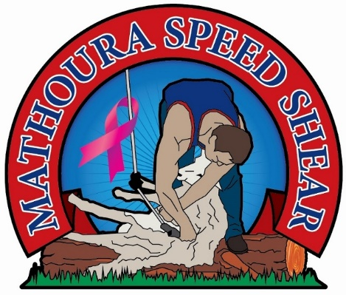

Photography Competition
2020

2020 will see the inaugural Photographic Competition included in the Mathoura Speed Shear event with great prises to be won.
The competition is open to anyone and everyone from smart phone snappers, camera enthusiasts to professional photographers.
There are four categories:
- Sheep/Shearing and/or Shearing Sheds
- Farming and/or Rural landscapes
- Rural portraits and/or people (including local event)
- Mathoura and surrounds (Murray River Council Shire)
Prizes will be awarded to school aged (5-14 years) and open (15 years and over) entries as well as an overall prize for best colour and best black and white entries.
Entries open 1 September 2020 and close 10th November 2020 and must be 8x10 inch (20.32x25.4 cm) print, mounted on A4 black card. (see the Conditions of Entry for further details).
All entries will be displayed during the event with winners announced during the day.
All enquiries are to be emailed to jedthe@hotmail.com

Mathoura Speed Shear Photography Competition
Terms and Conditions

All entries must be submitted in accordance with these terms and conditions. Each entrant agrees to the terms and conditions of this competition. No responsibility will be accepted by the Mathoura Speed Shear Committee for lost, late or incomplete entries.
- All entries must be the original, bona fide, unaided work of the entrant
Categories:
  - Sheep/Shearing and/or Shearing Sheds
  - Farming and/or Rural landscapes
  - Rural portraits and/or people (including local events) MURRAY RIVER COUNCIL SHIRE
  - Mathoura and surrounds (MURRAY RIVER COUNCIL SHIRE)
- Prizes will be awarded to:
  - school aged (5-14 years)
  - open (15 years and over)
  - Best overall colour photograph
  - Best overall black and white photograph
- Entry Fees:
  - School aged (5-15 years) $5 for up to 5 entries
  - Open (16 years and over) $5 for one photo, $15 for 3 photos $20 for 5 photos
- Entries will only be received from 1st September 2020 to 5pm 10 November 2020 by post (Anne Robertson 41A Livingstone Street, Mathoura) or hand delivered to the Mathoura Transaction Centre, Cobb Highway Mathoura.
- All entries and must be 8x10 inch (20.32x25.4 cm) print, mounted on A4 black card AND
- All entries MUST also be emailed to jedthe@hotmail.com for promotional purposes
- Entrants to this competition will allow the Mathoura Speed Shear Committee a non-exclusive, royalty free licence to use, reproduce, publish, distribute, communicate and broadcast their photographs in any digital or printed media formats related to the Mathoura Speed Shear Event. Photographers will be acknowledged where possible
- Entries can be landscape or portrait in orientation
- Entries can be in colour or black and white
- Each entry must have an identifying label with the entrant’s full name, email or contact phone number, category and age section entered on the back of each entry
- Entry fees are due and payable at the time of entry, paid in cash or direct deposit (email jedthe@hotmail.com for bank details)
- Entries featuring people, must have the consent of each person featured (the consent of a parent or guardian of children under 18 years of age)
- Entries may be refused where privacy rights have been deemed to be compromised, or no evidence of consent has been granted
- The Mathoura Speed Shear Committee reserves the right to exclude any entry deemed unsuitable for public exhibition
- Winners will be announced, and prizes awarded on the Event 16th November 2020. Winners not present at the event will be contacted after the event
- Judging will be based on originality, subject, composition and representation of the category entered
- Judges decisions are final
- Entries will not be returned unless the entrant makes arrangements to collect their entries at the conclusion of the exhibition 30 November 2020
- The Mathoura Speed Shear Committee will exercise all reasonable care in the handling of entries, but will not be responsible for any loss, theft or damage whilst in its custody
- The Mathoura Speed Shear Committee reserves the right to use its discretion in all matters. Should a dispute arise for which no terms or conditions have been identified, the committee’s decision will be final and no correspondence will be entered into.

Declaration: I acknowledge that I have read and understand the conditions of entry and agree to be bound by them.

Signature ………………………………………………………………………………….….… Date ……………………………………
Must be sighed by a parent or guardian if under 18 years of age

